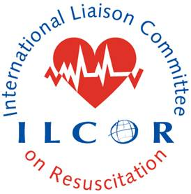This document provides a checklist of requirements that should be completed and checked by the SAC rep on the writing group (ESR KSU pathway). Once this checklist is completed and all requirements are met the SAC rep submits the checklist and the final CoSTR and EtD documents for SAC peer reviewers independent of the taskforce and the writing group.
ILCOR CoSTR Content Checklist

CoSTR Title:
Date of SAC rep completion of Checklist Review:
Verified by SAC rep (name):
Each item should comply with the current version of the CoSTR instructions document on ILCOR.org

Disclaimer for why CoSTR is marked ‘DRAFT’

CoSTR Citation

Methodological introduction)

Citation for systematic review and link to Pubmed (when available)

Inclusion of PICOST – comply with the version approved by CEE

Inclusion of PROSPERO registration number

Consensus on science

Treatment recommendations

Justification and technical remarks – narrative reporting of EtD Framework incorporating values and preferences

Knowledge gaps (ensure format is correct)

References listed alphabetically as per format

List of authors / collaborators approved by TF chair following CEE publication process and output document

Collaborator emails of approval included with submission, verifying compliance with publication policy

Conflict of interest is declared

All relevant Evidence to Decision Tables are included

Reviewer notes to the SAC peer reviewers:

