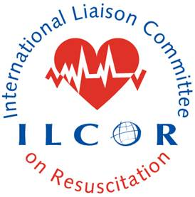

ILCOR 10 Steps to improve IHCA – Title of a Case Study (delete all in blue from the template, send it to: ilcor@heart.org)

Aim: The spirit of the case studies is to inspire continuous quality improvement. They are not meant to be scientifically rigorous reports but examples of real-world experiences of implementing programmatic improvements of In-Hospital Cardiac Arrest (IHCA). The average word length should be about 800 words, however can be less. Please use the following framework:

Background: Include a brief background of the system and the focal area for improvement.
Ask yourself, “Why is this important?”

Steps Taken: Provides a summary of the intervention, planned actions, and if possible measurements of success.

Challenges: Discusses barriers to implementing change and strategies for overcoming them, or enablers that helped in your project. This is the secret sauce of the case study and provides readers with perspective on how to address similar challenges at their own institutions. We highly encourage transparency in this section.

Results: The results of the intervention, both qualitative and quantitative (visuals with photos or graphs are encouraged).

Outlook: A concise summary (about two sentences) of how the intervention was useful and future plans.

References: Please provide any articles (if applicable) pertinent to your case study, limit to five.

Contact information: A contact name and email address. The URL of a web page (if existing). Please provide the names of all authors and their affiliation too.

