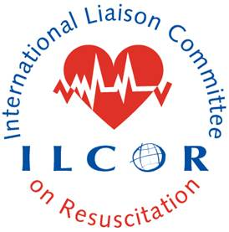 This document provides a checklist to guide systematic review lead authors and Scientific Advisory Committee (SAC) members in their review of PROSPERO registration. The SR lead author completes this and the SAC representative on the writing group reviews and signs off on the checklist and approves it prior to the SR lead author uploading the registration to PROSPERO.

ILCOR Prospero Registration Submission Checklist

SR and Prospero Title:
Lead author:
Date registration received:
Date SAC member completed checklist review:
SAC member:

This should be compliant with the current PROSPERO registration template and the approved PICOST and the authorship guidelines and the publication process and output (ilcor.org)

acknowledgement of funding from ILCOR

acknowledgement of any COIs

Inclusion of the PRISMA checklist

use of GRADE methodology

inclusion of comprehensive GRADE tables and evidence profile(s)

Inclusion of updated search results

submitted on behalf of the relevant primary and secondary ILCOR task force(s) (nodal PICOST may have involvement of more than one Task Force)

acknowledgment of contribution of the information specialist through authorship or collaborator or acknowledgment only

presentation of meta-analytical statistical results using RR, RD or ARR and patients with outcome/1000 patients and CIs from GRADE evidence tables when a meta-analysis was performed or use of standardized wording when a meta-analysis was not performed.

Consistent with original PICOST scope and final prioritized outcomes

List of authors consistent with original PICOST or if changes approved by primary Task Force Chair and SAC rep

Reviewer notes:

