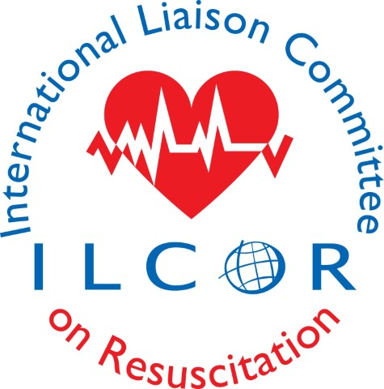
ILCOR APPEALS POLICY AND PROCEDURES

- Basic Principles
- ILCOR Task Force Chairs, Expert Systematic Reviewers, Scientific Advisory Committee Members, Task Force Members, Writing Group members and ILCOR Staff are expected to perform their duties in accordance with commissions of the respective groups.
- Rules relating to ILCOR publications and products including systematic reviews, scoping reviews and evidence updates have been created by ILCOR and generally follow the International Committee Journal Medical Editor (ICJME) process for determining authorship, collaborators and acknowledgements. High standards and adherence to these principles are expected.
- Expectations for performance, work and work products of the respective groups previously mentioned should be clearly specified before work begins.
- Evaluations must occur without departing substantially from previously published ILCOR procedures.

- Grounds for appeals are as follows:
  - The application of criteria not included in the respective commissions found in the Articles of Incorporation or Internal Rules, SAC commission or COI guiding principles or Terms of Appointment.
  - Sexual harassment or discrimination.
  - Funding for educational endeavors or delegate travel support.

- Appeal Process
a. Whenever a decision is in dispute, the individual may appeal to the chair of said committee for an informal review.
b. Formal appeals are limited to the grounds stated in item 1. above.
c. The individual’s first formal appeal should be directed to the chairperson at the local level.
d. The local chairperson shall respond in writing to a formal written appeal within ten days of receiving the appeal.
e. If the issue is unresolved, the individual may within ten days lodge an appeal in writing with the ILCOR Board.
f. The individual filing the appeal shall be notified in writing of the ILCOR Board decision regarding the formal appeal within thirty days of its receipt

- Procedures for Appeals
Individual’s written appeals and subsequent formal responses shall follow these guidelines.
  - To initiate the appeal process, the individual shall submit a written statement detailing his/her objections, along with supporting documentation, to the Task Force Chair.
    - Your letter should be concise with your points made clearly and brief.
    - Your letter should draw direct connection to the ground(s) for appeal you have selected.
    - Your letter should specifically state the issue/decision/sanction or sanctions you are appealing based on the ground(s) for appeal.
    - You can identify any additional information you deem appropriate and relevant.
    - You can propose an alternative outcome.

  - If the individual receives an unsatisfactory response in writing or no response within 10 days of having lodged the complaint with the Task Force chair, he/she may appeal to the ILCOR Board.
  - The ILCOR Board shall review the complaint and respond in writing within 30 days. Within this time period, the Board may seek the advice of the COI committee or others if necessary.
  - The Board member that conducts a review must specify their authority.
  - The Task Force chair overseeing the individual filing an appeal shall be invited by the Board to reply in writing to the objections of the individual and submit this response to the Board.
  - The individual shall submit a copy of the written statement initially submitted to the Task Force chair in addition to a statement explaining his/her dissatisfaction with the Task Force chair solution(s) proposed.
  - The ILCOR Board shall submit their decision in writing within 30 days of receipt of the complaint.
  - The Board’s decision is the final decision of ILCOR.
  - Any meetings held in relation to the appeal shall provide parties the opportunity to present additional information orally or in writing. No additional persons should be permitted at such meetings without advance approval by the Board member conducting the review, as appropriate.

- Additional information regarding procedures, commissions, etc. can be found at ilcor.org.

