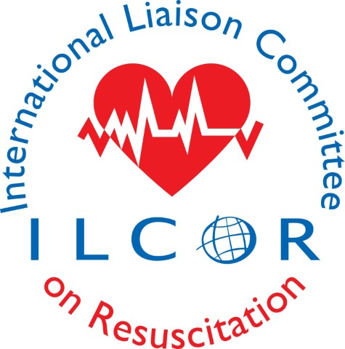

COI Guidance Document
ILCOR COI Principles and Rules, by Role (leader, participant)

- Purpose: The purpose of ILCOR’s COI policies and procedures is to protect the integrity of the consensus on science with treatment recommendations process, and to ensure those involved in ILCOR’s processes and those who use ILCOR’s products are confident that the results are not influenced by either commercial or intellectual bias, to the highest extent possible. Effective COI management includes disclosure and transparent management of potential conflicts when they arise, with good documentation of actions taken.
- Written disclosure: All participants in the ILCOR process (regardless of role) must have an up-to-date written COI disclosure on file with ILCOR and routinely accessible to TF chairs. Each participant must update this at least annually and whenever substantive changes occur. Substantive changes are those which create or change a relationship that could be viewed as causing a conflict with ILCOR’s activities. Participants include all volunteers, staff, ESRs, KSU staff, observers, those who comment on drafts or suggest PICOSTs, and all others involved in ILCOR processes.
- Ability to view disclosures: Each participant must be able to view any other participant’s COI disclosure during a meeting or between meetings at ilcor.org. This can also be done through a written list of participant disclosures at meetings. At large conferences where resuscitation science is discussed, a disclosure slide should be projected for every speaker (presenter or participant) during the entire time they speak where possible. Participant’s disclosures must also be available for the public to view.
- Raising concerns: If any participant identifies a potential COI issue, he/she should raise it with the leader of the group involved (or with a COI monitor, if that activity has one; see below). If that is not possible, then he/she can raise it with the leaders of ILCOR or the COI co-chairs.
- Realtime verbal disclosure: If any participant (including members, leaders, observers, staff) has a direct conflict related to an issue being discussed, that participant must also verbally disclose his/her relationship at that time. In general, it is sufficient to mention this once during that discussion.
- Limits on participation: In general, a participant with a potential conflict will be allowed to participate in the discussion after disclosing the relationship (the equivalent of giving testimony in a trial) but will abstain from any votes on the issue. Rarely a conflict may be so significant or complex that the leader may require the participant to recuse him/herself from the discussion, or even ask the participant to leave the room. The decision to limit or permit participation will be made by the group’s leaders. If needed, leaders can seek advice from ILCOR leaders and/or the COI co-chairs.
- Leaders’ responsibilities: Leaders of groups and processes include leaders of Task Forces, Committees, Working Groups, Writing Groups and teams allocated to reviewing PICOSTs/topics. While COI disclosure and management applies to every participant, it is especially important for leaders to have few conflicts, since leaders have greater influence on every step in the process, from group membership to topic selection to final drafting. A COI checklist may be helpful to ensure leaders have reviewed COI for each step in the CoSTR process, from selecting members to serve on task forces and groups, to selecting questions, to KSU or ESR selection, to evidence evaluation, and to CoSTR drafting and finalization.
- Leaders review disclosures: Each leader must review COI disclosures of those involved in his/her process prior to assignment of responsibilities to identify potential COI concerns. These concerns should be investigated and, if substantive, resolved through reassignment. If no appropriate alternative exists, the leaders should document the risk and steps taken to minimize the conflict, such as appointment of another participant without a conflict to assist in the task. When in doubt, leaders should request advice from other leaders and/or the COI co-chairs. Leaders and groups should take special care to avoid potential COI in selection of questions, seeking individuals with expertise in specific areas, in assignment of ESR or KSU, PICOST lead, and other roles involved in including/excluding and evaluating evidence.
- Leader reminders: At all meetings the leaders should remind participants of COI policies including the requirement to verbally disclose COI whenever discussing a topic directly related to the participant’s relationships.
- Leaders of KSUs: Since a KSU is delegated the responsibility for selection and evaluation of evidence, the KSU leadership must ensure management of potential COI among KSU staff. All KSU staff must complete annual ILCOR COI disclosure as noted above. Furthermore, KSU leaders must ensure that if any of its workers have relevant financial or intellectual conflicts related to the topic assigned to that KSU, then those workers are not involved in that topic.
- Documentation: A real-time record of COI-related discussions and actions is essential, especially if questions are raised later about the appropriateness of decisions or assignments. Because the leaders are usually fully engaged in conducting the business of the meeting, the expectation is that the leader will assign one participant to serve as COI monitor for the meeting, to ensure the participants are reminded about the requirements surrounding COI disclosure and to record any COI-related actions.
- Links to COI disclosures: Every ILCOR document (e.g. PICO, PICOST, CoSTR draft, final CoSTR) should have relevant COI disclosure links, so viewers can easily check disclosures on those who worked on that product.
- Intellectual COI: In general, relationships with commercial entities raise more obvious potential conflicts and higher risk to the public trust than the potential conflicts raised by academic work of an individual. Intellectual conflicts can, however, be an important source of potential bias. Having published in a field or currently engaged in research in that field should not necessarily exclude an individual from taking a role in the ILCOR process. At times, however, a participant’s academic work can present a potential conflict, such as when grant funding could be influenced by an outcome of an analysis, or when currently involved in a clinical trial directly related to a PICOST question. Managing potential intellectual conflicts requires judgement of the leaders of the group in which the individual is working. In such cases the leaders need to balance the desire to have the best scientifically qualified expert with the need to ensure independence in evidence evaluation and interpretation. The leaders must take into account whether the individual’s publications and opinions pose a significant enough potential conflict that it might risk the credibility of the analysis. In general, individuals should not extract data or do bias assessments for studies of which they are an author. If in doubt, the leaders of the group can seek input from other ILCOR leaders and/or the COI co-chairs. The group and leaders often are aware of the potential intellectual conflicts of a participant or leader. Nonetheless, individuals should verbally remind the group of their past and planned work that relates to the topic under discussion so a thoughtful, prospective decision on work assignments can be made and documented. When such potential intellectual conflicts are not surfaced in advance, it may delay completion and require rework, such as adding independent reviewers to repeat some of the analyses.
- Conflicts arising from multiple roles in the process. A special case of potential for bias occurs when an individual has a role in drafting either a systematic review (SR) or a CoSTR, and then that individual is part of a group that is tasked with reviewing that product. For example, this happens in the current workflow when a member of the SAC is assigned to a PICOST and works with an ESR or KSU to create the systematic review, qualifying as a co-author on that SR. When SAC is tasked with reviewing that SR for methodologic appropriateness, it would be expected that a different member of the SAC will perform that review, so the original SAC member assigned to that PICOST is not reviewing his/her own work.

